**GUIDELINES FOR RESETTING THE LMS PASSWORD**

**TO GET YOUR STUDENT EMAIL IDs, OUR STUDENT ENGAGEMENT TEAM WILL GUIDE YOU THE PROCESS**

**STEP 1:** Click on the Lost password? as shown below.

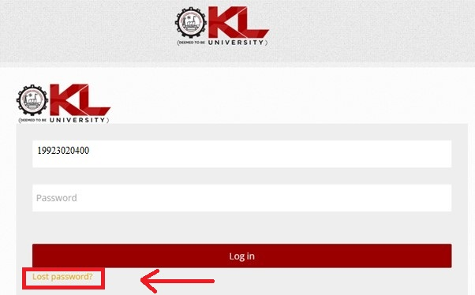

**STEP 2:** Provide your username or email address as shown below.

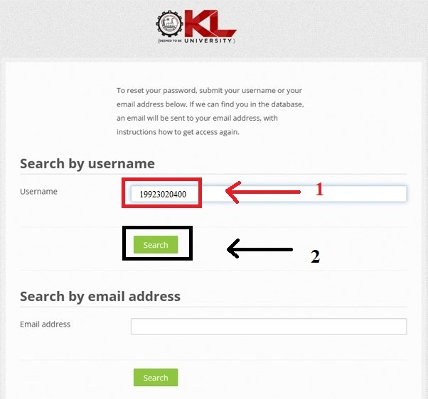

**OR**

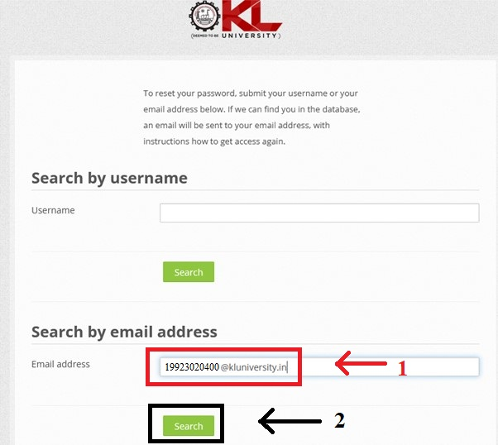

Then you will be re-directed to this page. 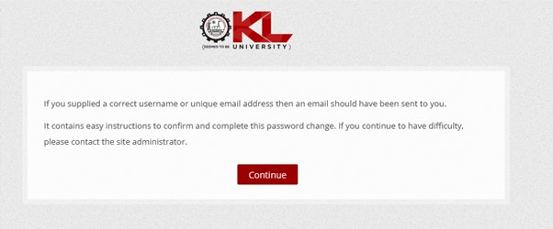

**Step 3:** Sign in to your outlook e-mail (Use the e-mail address that was provided by the university (Example: [19923020400@kluniversity.in)](mailto:19923020400@kluniversity.in)))

Then you will get an e-mail as shown below.

Use the URL that was given in the e-mail.

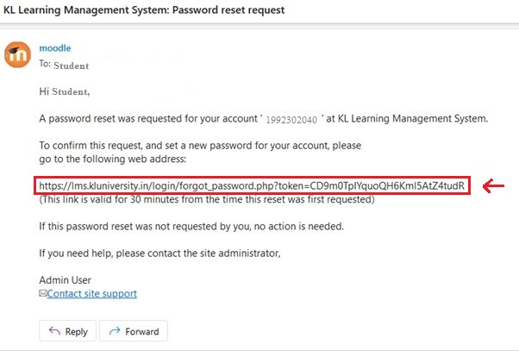

**Step 4:** Paste the URL in another tab as shown below and click enter.



**Step 5:** Provide your new password as shown below and click Save changes.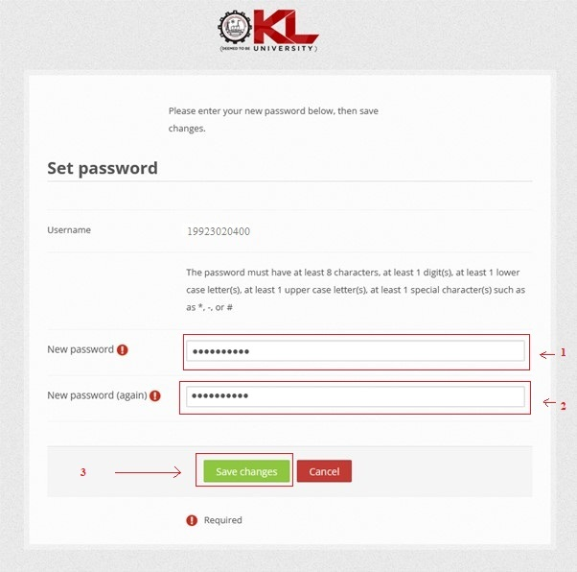

**Step 6:** You will get a prompt that “Your password has been set” as shown below.

